**ORDERONTHEGO – ON-DEMAND FOOD ORDERING SOLUTION**

**A Full Stack MERN Based Web Application**

**1. INTRODUCTION**

## 1.1 Project Overview

OrderOnTheGo is a full-stack MERN (MongoDB, Express.js, React.js, Node.js) web application designed to simplify and digitize the food ordering process. The platform provides an integrated environment where Customers, Restaurants, and Administrators interact through a centralized and secure system.

The application enables customers to browse food items, add them to a cart, place orders, and complete payments through a secure online payment gateway. Restaurants can manage their menus, process incoming orders, and update order statuses through a dedicated dashboard. Administrators oversee the entire system by monitoring users, approving restaurant registrations, and ensuring smooth platform operations.

The system is built using a modular and layered architecture. React.js handles the dynamic and responsive frontend interface, while Node.js and Express.js manage backend logic and API routing. MongoDB serves as the database for storing structured data such as user accounts, restaurant details, food items, orders, and payment records. Authentication is secured using JWT (JSON Web Tokens) and bcrypt encryption.

Overall, OrderOnTheGo demonstrates real-world full-stack development concepts including role-based authentication, RESTful API communication, payment integration, and database management within a scalable and maintainable architecture.

## 1.2 Purpose

The primary purpose of OrderOnTheGo is to develop a secure, scalable, and user-friendly online food ordering platform that addresses real-world operational challenges in restaurant management and customer ordering systems.

* The specific objectives of the project include:
* To provide customers with a convenient and efficient digital food ordering experience.
* To enable restaurants to manage menu items, track orders, and update order status through a structured dashboard.
* To implement secure authentication and authorization mechanisms using JWT and bcrypt.
* To integrate a reliable payment gateway for safe and verified online transactions.
* To create a centralized admin control system for monitoring users, restaurants, and platform activities.
* To design a scalable architecture using the MERN stack that supports future enhancements and expansion.
* The project aims to bridge the gap between customers and restaurants through a modern digital solution that ensures efficiency, transparency, and security.

# 2. IDEATION PHASE

The Ideation Phase focused on identifying real-world problems in food ordering systems and designing an effective digital solution. This phase involved understanding user needs, analyzing existing systems, brainstorming possible solutions, and selecting the most feasible and scalable approach using modern technologies.

## 2.1 Problem Statement

* In traditional food ordering systems, customers often experience inconvenience, long waiting times, lack of order transparency, and limited payment options. Manual order management in restaurants can lead to errors, miscommunication, and inefficient workflow handling. Additionally, administrators lack centralized control over operations, making monitoring and regulation difficult.
* Key problems identified include:
* Lack of a centralized digital ordering system.
* Absence of secure authentication and role-based access.
* Inefficient cart and order management processes.
* Limited transparency in order tracking.
* Insecure or unreliable payment handling.
* No unified system connecting customers, restaurants, and administrators.
* Therefore, there is a need for a secure, scalable, and efficient web-based platform that simplifies food ordering, enhances transparency, and improves operational management.

## 2.2 Empathy Map Canvas

* To better understand user needs, an empathy map was created focusing on three primary stakeholders: Customers, Restaurants, and Admin users.

### Customers

* **Think & Feel:**
* Want quick and hassle-free food ordering.
* Expect secure payment and order confirmation.
* Desire real-time order updates.
* **See:**
* Multiple food delivery apps with complex interfaces.
* Delays and confusion in manual ordering systems.
* **Say & Do:**
* Prefer browsing menus easily.
* Add items to cart and expect smooth checkout.
* Track orders after placing them.
* **Pain Points:**
* Payment failures.
* Order mismanagemen
* Lack of clear tracking.
* **Needs:**
* Secure login.
* Smooth ordering workflow
* Transparent order status updates

.

### Restaurants

* **Think & Feel:**
* Need structured management of menu and orders.
* Want a simple system to handle customer requests.
* **Pain Points:**
* Manual order errors.
* Difficulty managing large order volumes.
* **Needs:**
* Dashboard to manage items.
* Order update functionality.
* Admin approval and system access control.

### Admin

* **Think & Feel:**
* Need centralized monitoring and control.
* Ensure secure platform operations.
* **Needs:**
* Manage users and restaurants.
* Approve registrations.
* Monitor transactions and system activity.
* The empathy analysis helped design a solution that addresses real user challenges and enhances overall system efficiency.

## 2.3 Brainstorming

* During the brainstorming phase, several ideas were evaluated:
* Simple restaurant listing website.
* Manual online order submission form.
* Static menu display system.
* Complete full-stack food ordering application.
* After evaluation, simpler approaches were rejected because they lacked:
* Secure authentication mechanisms.
* Role-based dashboards.
* Payment gateway integration.
* Order tracking features.
* Centralized management.
* The final idea selected was a complete MERN-based food ordering system that includes:
* Role-based authentication.
* Cart and order management.
* Secure payment integration.
* Admin monitoring and approval system.
* Scalable backend architecture.
* The MERN stack was chosen because it provides flexibility, high performance, and real-world industry relevance. This decision ensured that the project demonstrates practical full-stack development skills while solving real operational challenges.

**3. REQUIREMENT ANALYSIS**

**3.1 Customer Journey Map**

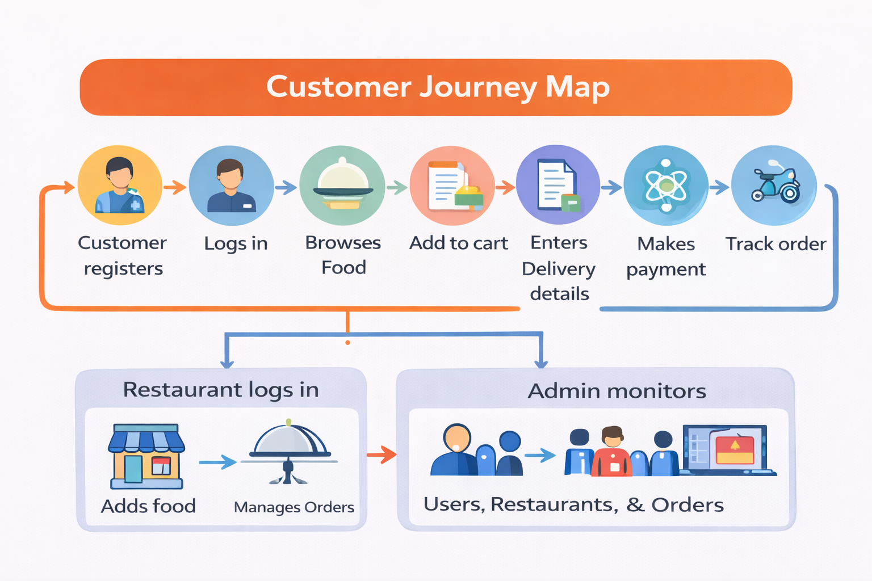

|  |  |
| --- | --- |
| User Type | Process Flow |
| Customer | Register → Login → Browse Food → Add to Cart → Delivery Details → Payment → Track Order |
| Restaurant | Login → Add Food → Manage Orders |
| Admin | Monitor Users → Monitor Restaurants → Monitor Orders |

**3.2 Data Flow Diagram**

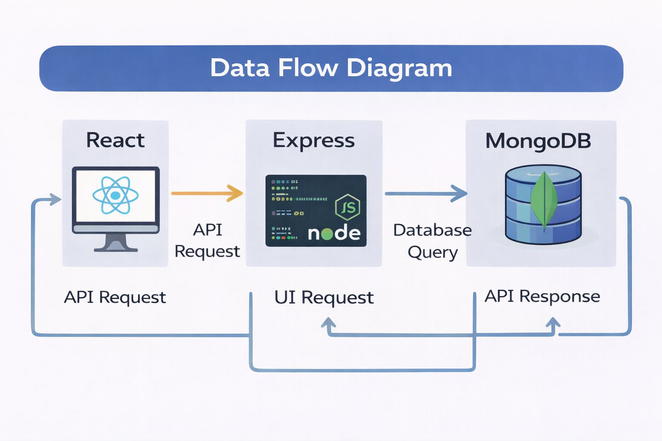

|  |  |
| --- | --- |
| Step | Process |
| 1 | React Frontend sends API request |
| 2 | Express Backend processes logic |
| 3 | MongoDB database interaction |
| 4 | API response returned |
| 5 | Frontend UI updated |

**3.3 Technology Stack**

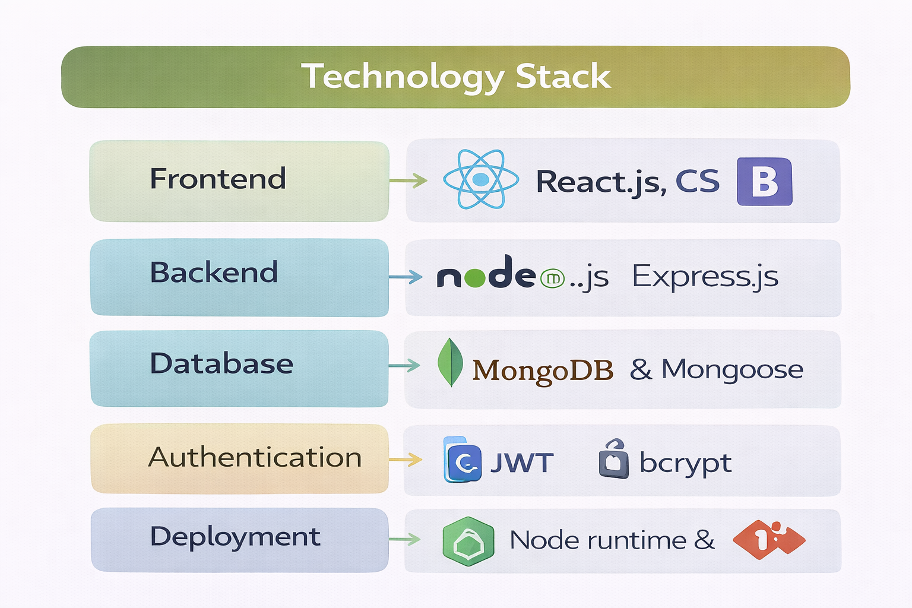

|  |  |
| --- | --- |
| Layer | Technologies |
| Frontend | React.js, CSS, Bootstrap |
| Backend | Node.js, Express.js |
| Database | MongoDB, Mongoose |
| Authentication | JWT, bcrypt |
| Payment | Razorpay |

**3. DESIGN PROJECT**

The system is designed using a modular architecture approach.

Separate modules handle authentication, food management, cart operations, order processing, and admin control.

Role-based access ensures system security.

REST APIs handle communication between frontend and backend.

MongoDB stores structured collections for Users, Restaurants, Food, Orders, and Payments.

**Solution Architecture:**

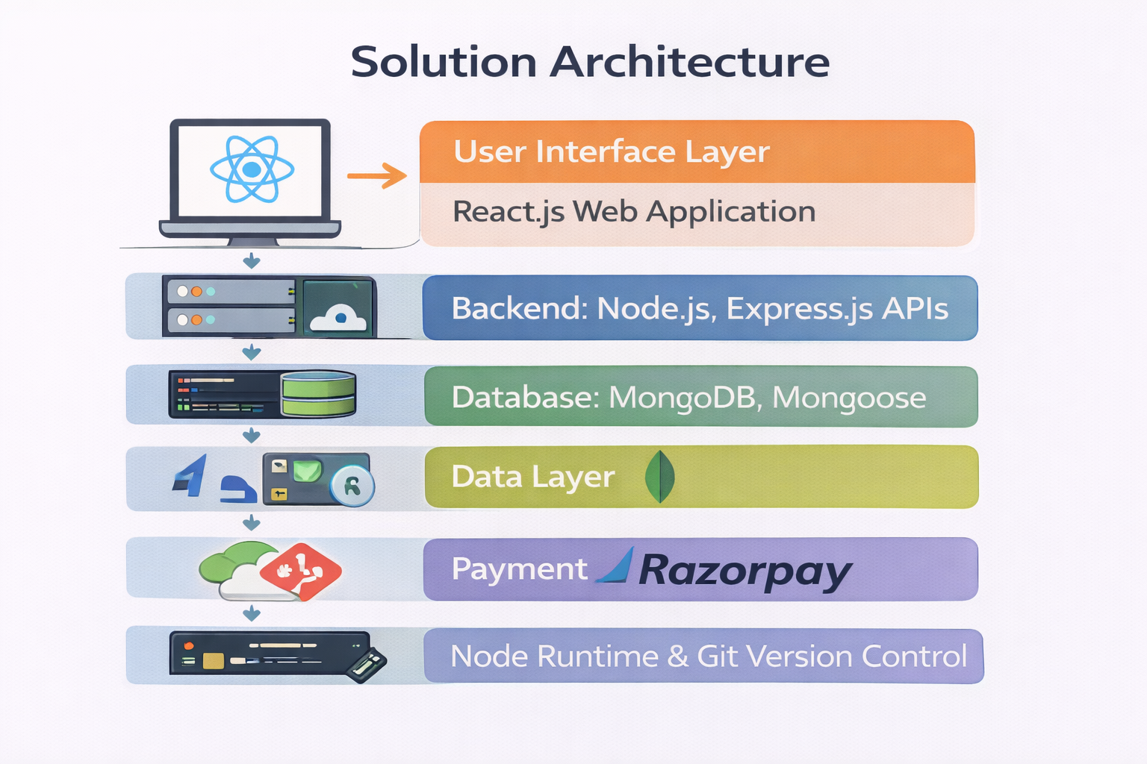

### 1. User Interface Layer (Frontend)

The User Interface Layer is developed using **React.js** along with CSS and Bootstrap for responsive design.

This layer is responsible for:

* Rendering dynamic web pages for Customers, Restaurants, and Admin users.
* Handling user interactions such as login, registration, browsing food items, adding to cart, and placing orders.
* Managing client-side routing using React Router.
* Sending API requests to the backend using Axios.
* Displaying real-time updates based on backend responses.

The UI layer ensures a smooth and interactive user experience while maintaining responsiveness across different devices.

### 2. Application Layer (Backend APIs)

The Application Layer is built using **Node.js and Express.js**.

This layer performs:

* Business logic execution.
* RESTful API routing.
* Order processing workflows.
* Food item management.
* Role-based access validation.
* Admin approval mechanisms.

Express middleware is used for request validation, authentication verification, and role authorization. This layer acts as the bridge between the frontend and the database.

### 3. Authentication & Security Layer

* Security is implemented using:
* **JWT (JSON Web Tokens)** for authentication.
* **bcrypt** for password hashing.
* This layer ensures:
* Secure login and registration.
* Encrypted password storage.
* Token-based session management.
* Role-based authorization (Customer / Restaurant / Admin).
* Protected API routes.
* JWT tokens are generated after successful login and must be included in subsequent requests to access protected endpoints.

### 4. Data Management Layer

* The Data Layer uses **MongoDB** with **Mongoose ODM** for schema modeling.
* Collections include:
* Users
* Restaurants
* Food Items
* Carts
* Orders
* Payments
* This layer is responsible for:
* CRUD operations
* Data validation
* Query optimization
* Relationship management using Object IDs
* Maintaining transaction consistency
* MongoDB ensures flexible and scalable NoSQL document storage.

### 5. Payment Integration Layer

* The system integrates **Razorpay** for payment processing.
* Responsibilities:
* Payment verification
* Transaction validation
* Secure payment flow
* Storing payment references in the database
* Ensuring order confirmation only after successful payment
* This layer enhances reliability and trust in the transaction process.

### 6. Deployment & Runtime Layer

* The application runs in the **Node.js runtime environment**.
* Deployment components include:
* Node server hosting
* Environment variable configuration (.env)
* Git version control
* Package management using npm
* This layer ensures the application can be deployed locally or on cloud platforms with scalability support.

# 4. PROJECT DESIGN

The Project Design phase focuses on translating system requirements into a structured technical solution. OrderOnTheGo is designed using a modular and layered architecture to ensure scalability, maintainability, security, and efficient workflow management. The design incorporates role-based access control, RESTful API communication, secure payment integration, and structured database management.

The system is divided into multiple modules including Authentication Module, Customer Module, Restaurant Module, Admin Module, and Payment Module. Each module operates independently while interacting seamlessly through backend APIs.

## 4.1 Problem–Solution Fit

During requirement analysis, several real-world challenges in food ordering systems were identified. The project design ensures that each problem is addressed with a clear and practical solution.

### Identified Problems and Corresponding Solutions:

**1. Difficulty in Convenient Food Ordering**  
Customers often face delays, complex interfaces, and unclear ordering processes.  
→ OrderOnTheGo provides an intuitive interface with easy navigation, quick browsing, and a seamless cart system for smooth order placement.

**2. Lack of Structured Restaurant Management**  
Restaurants may struggle with manual order tracking and menu management.  
→ A dedicated Restaurant Dashboard allows structured management of food items, order updates, and customer requests.

**3. Absence of Centralized Monitoring**  
Without centralized control, platform management becomes inefficient.  
→ An Admin Dashboard enables monitoring of users, restaurant approvals, and order activities in a single interface.

**4. Security Risks in Online Systems**  
Unsecured systems are vulnerable to data breaches and unauthorized access.  
→ JWT-based authentication and bcrypt password hashing ensure secure login and protected API routes.

**5. Unreliable Payment Handling**  
Manual payment methods may lead to transaction errors and order mismatches.  
→ Razorpay integration ensures secure and verified online transactions before confirming orders.

**6. Lack of Transparency in Order Tracking**  
Customers may not know the current status of their orders.  
→ The system provides order tracking features that update order progress in real time (status-based updates).

This structured problem–solution alignment ensures that the application directly addresses real-world operational gaps.

## 4.2 Proposed Solution

The proposed solution is a full-stack MERN-based web application that integrates frontend, backend, database, and payment components into a unified system.

### Key Components of the Proposed Solution:

**1. Role-Based Dashboard System**  
The system supports three user roles:

Customer

Restaurant

Admin

Each role has a dedicated dashboard with restricted access permissions based on JWT authentication and middleware authorization.

**2. Food Listing and Cart Management**  
Restaurants can add, update, and remove food items. Customers can browse available items, add them to a cart, modify quantities, and proceed to checkout.

**3. Secure Authentication Mechanism**  
JWT tokens are generated during login and verified on protected routes. Passwords are encrypted using bcrypt before storage in the database.

**4. Order Processing and Status Management**  
Orders are stored in the database with structured fields such as user details, items, payment status, and order status. Restaurants can update order status, and customers can view real-time updates.

**5. Payment Integration**  
Razorpay is integrated to ensure secure online payments. Orders are confirmed only after successful payment verification.

**6. Scalable Architecture**  
The system follows a layered architecture:

React Frontend (Presentation Layer)

Express Backend (Business Logic Layer)

MongoDB (Data Layer)

Payment & Authentication Layer

This modular design ensures flexibility, easy maintenance, and future feature integration.

The proposed solution effectively combines usability, security, performance, and scalability, making OrderOnTheGo a practical and production-ready food ordering system.

# 5. PROJECT PLANNING & SCHEDULING

Proper planning and scheduling were essential to ensure timely and structured development of OrderOnTheGo.

The project followed a systematic development lifecycle:

Requirement Analysis → System Design → Development → Testing → Deployment

Each phase was carefully executed to maintain quality and reduce errors.

## 5.1 Project Planning

The project planning phase included:

Identifying system requirements and user roles.

Designing database schemas and API structure.

Dividing tasks among team members.

Setting milestones for frontend and backend development.

Allocating time for integration and testing.

Conducting validation and performance evaluation before final submission.

The development was organized into modules:

Authentication Module

Customer Module

Restaurant Module

Admin Module

Payment Module

This structured planning approach ensured systematic progress, proper coordination, and successful project completion within the scheduled timeline.

**6. FUNCTIONAL AND PERFORMANCE TESTING**

**6.1 Functional Testing**

|  |  |
| --- | --- |
| Test Case | Description |
| User Registration | Verify account creation |
| Login | JWT authentication validation |
| Add to Cart | Cart item insertion test |
| Order Placement | Order workflow validation |
| Admin Approval | Restaurant approval verification |

**6.2 Performance Testing**

|  |  |
| --- | --- |
| Test Type | Objective |
| Concurrent Users | Handle multiple sessions |
| API Response Time | Measure backend speed |
| Database Queries | Optimize performance |
| Server Load | Monitor CPU and memory usage |

**7.Results:**

**ADMIN :**

**MODULE OUTPUTS**

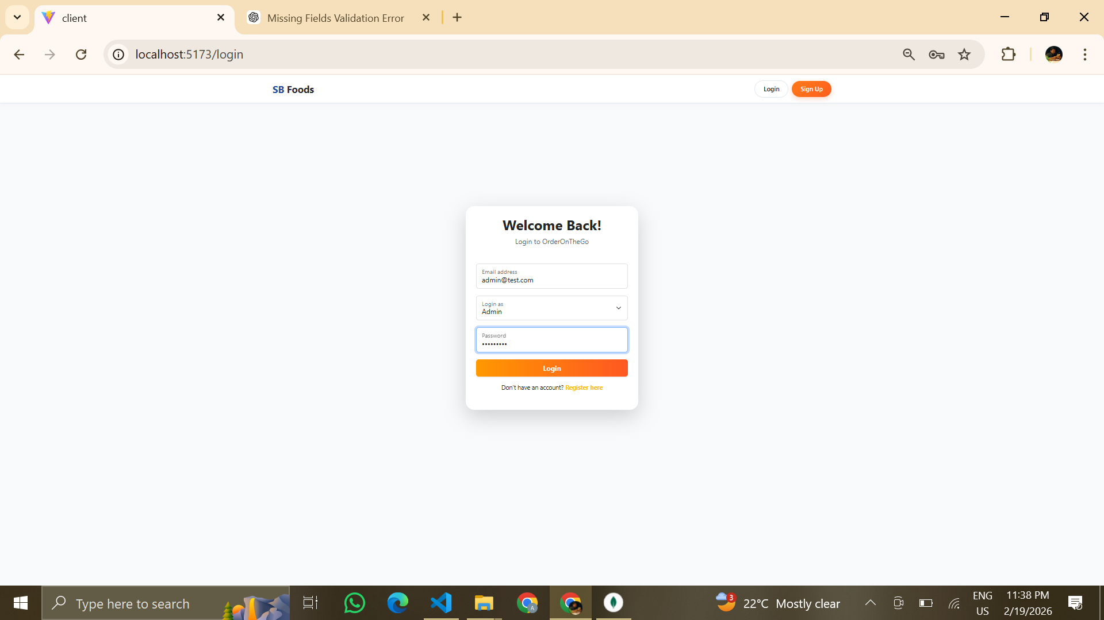

Figure: Admin Login Page

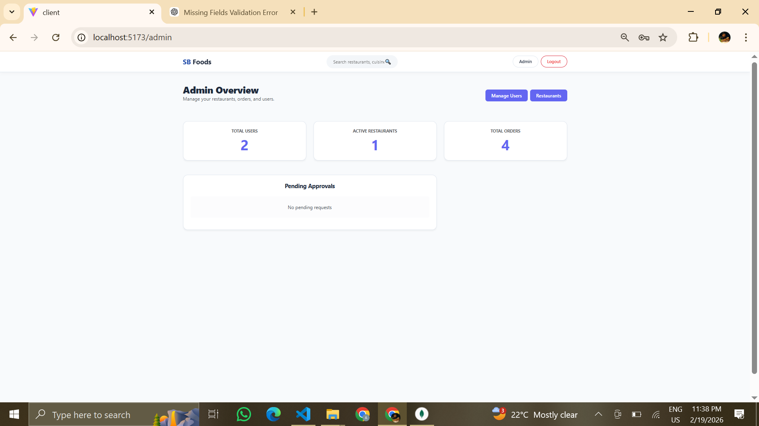

Figure: Admin Dashboard

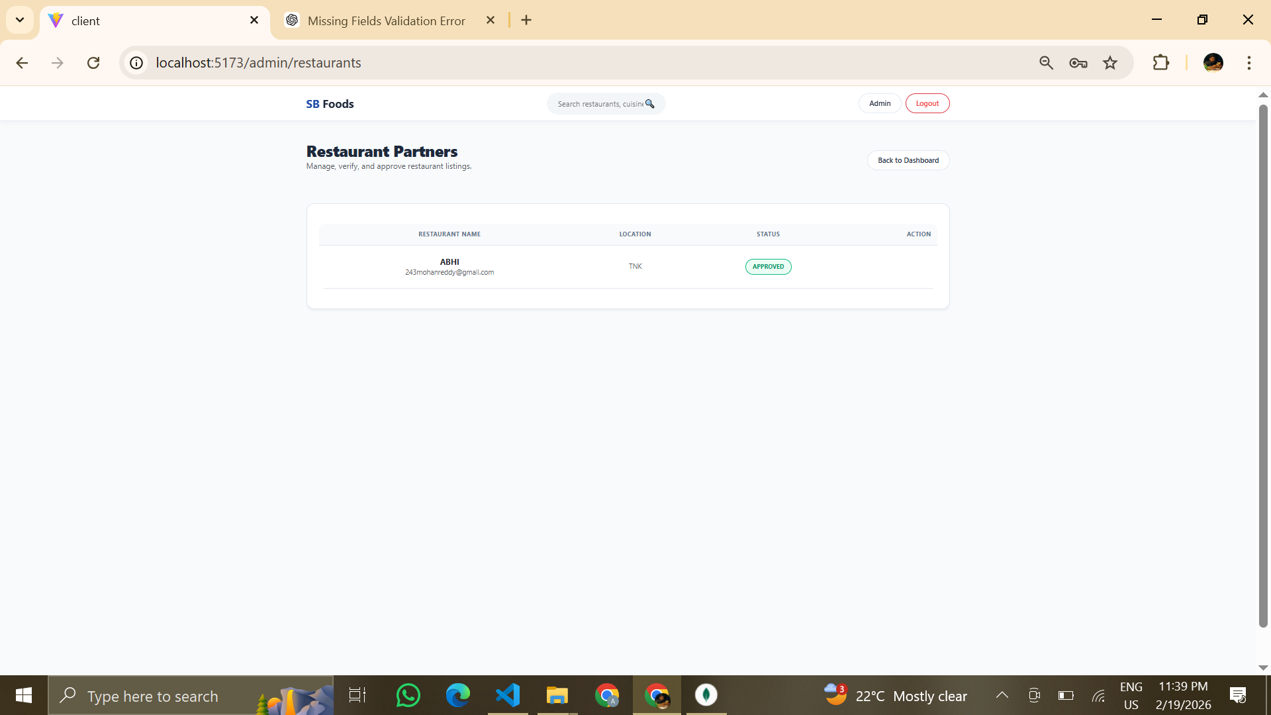

Figure: Manage Restaurants

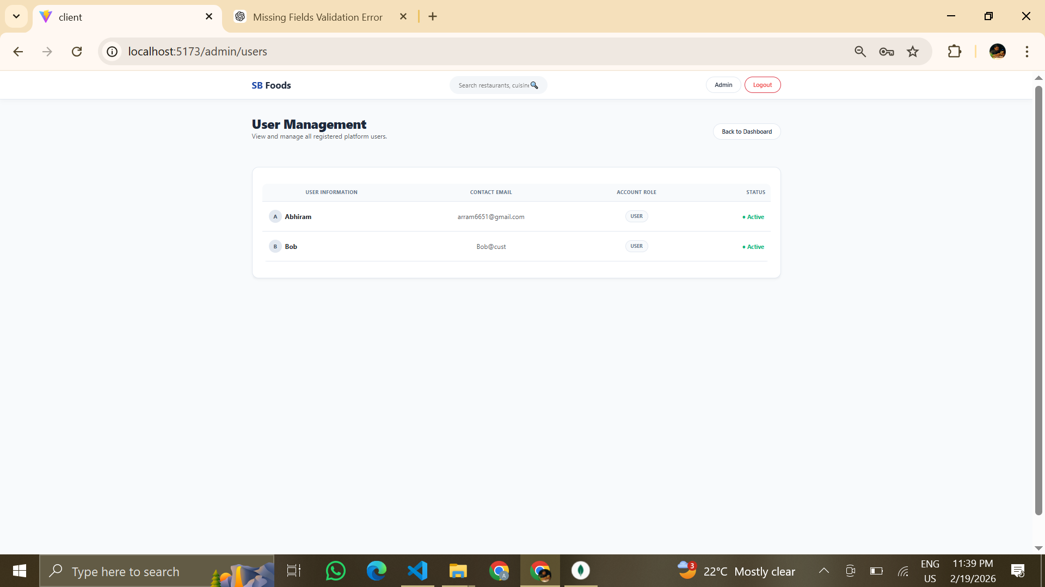

Figure: Manage Users

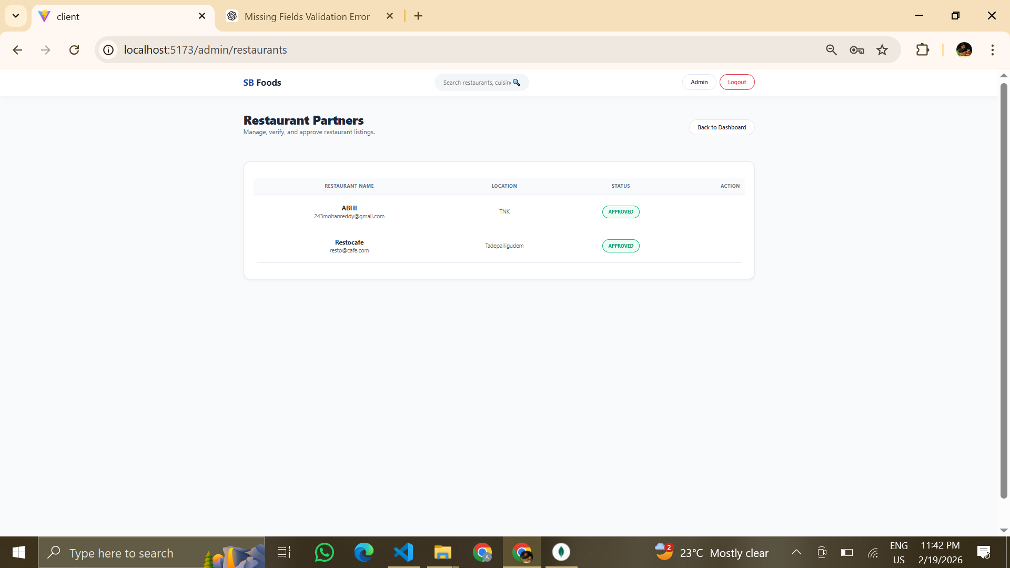

Figure: Restaurant Approval

**CUSTOMER:**

**MODULE OUTPUTS**

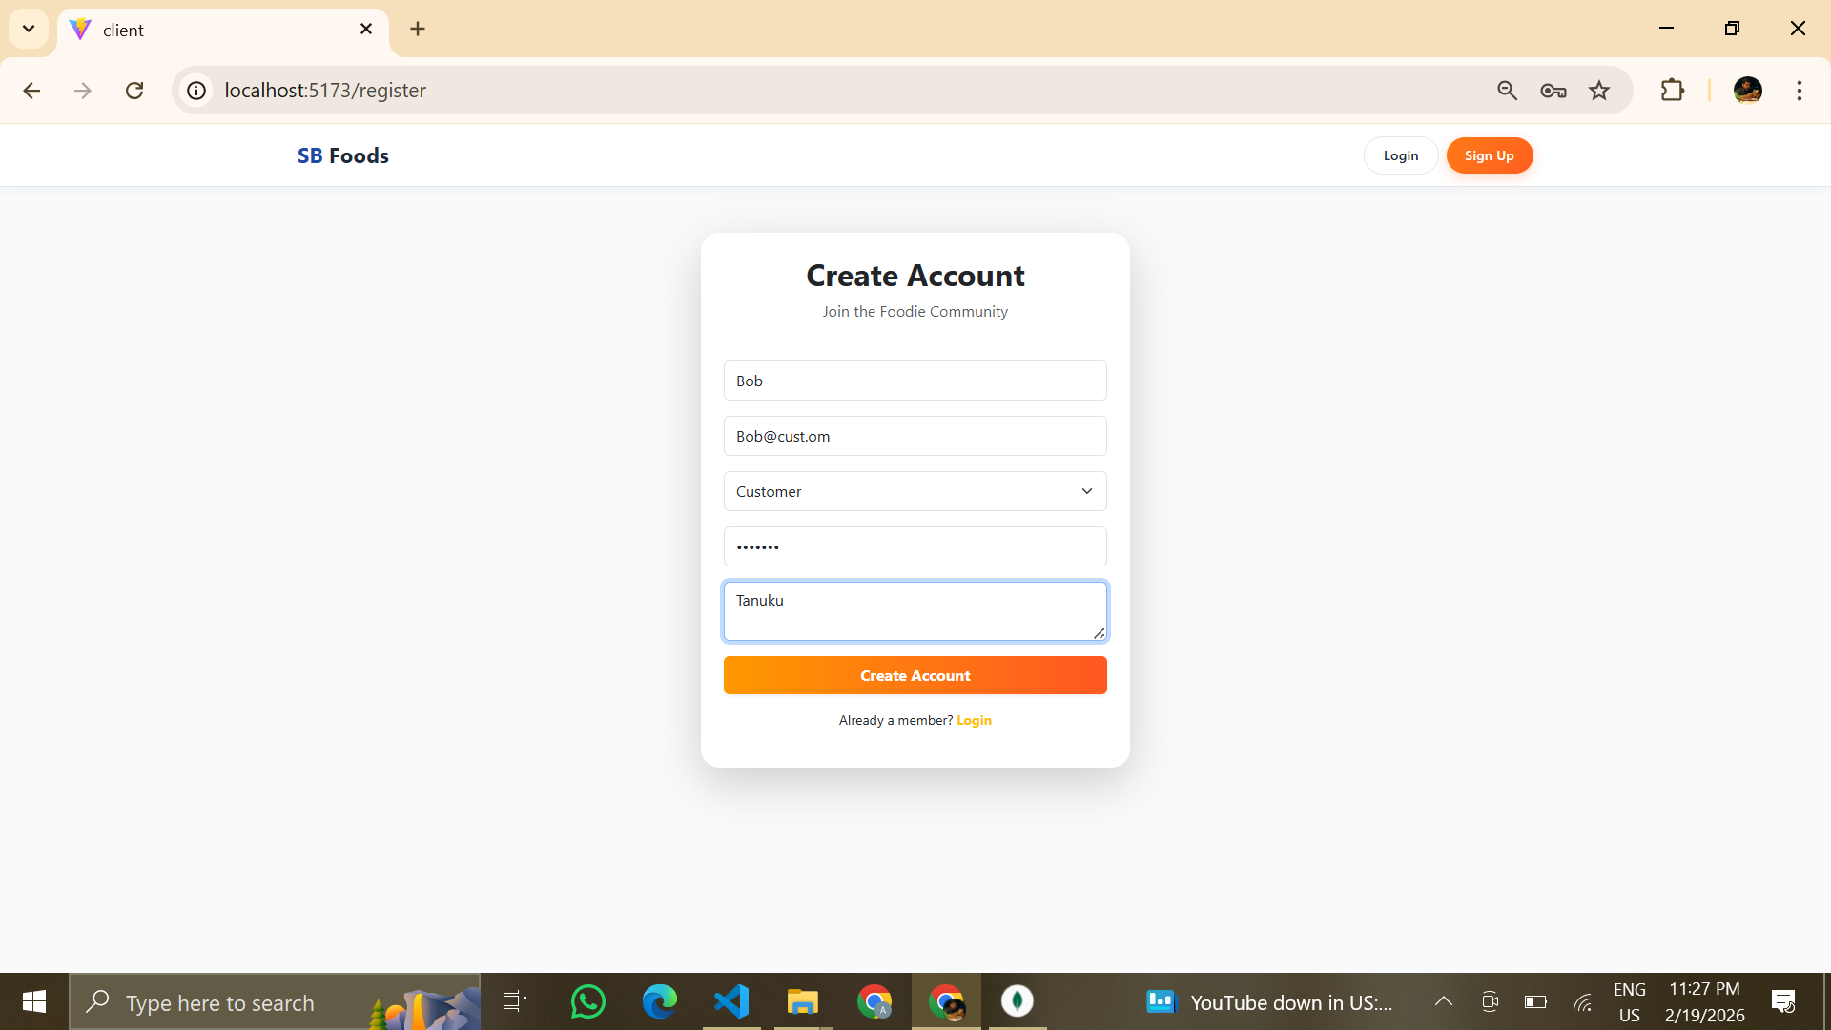

Figure: Customer Registration

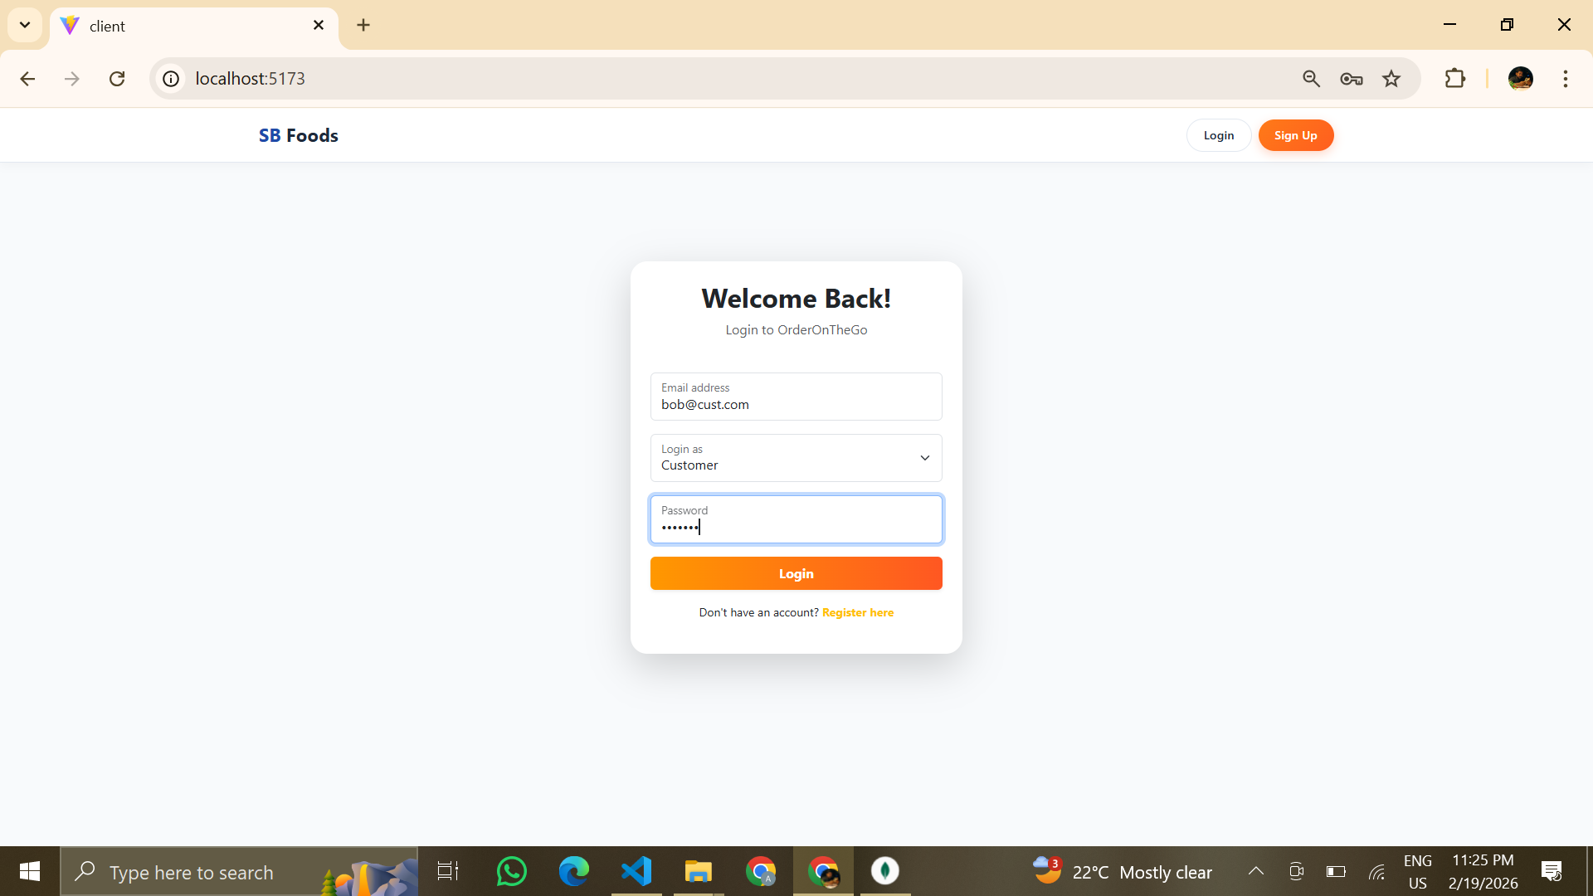

Figure: Customer Login

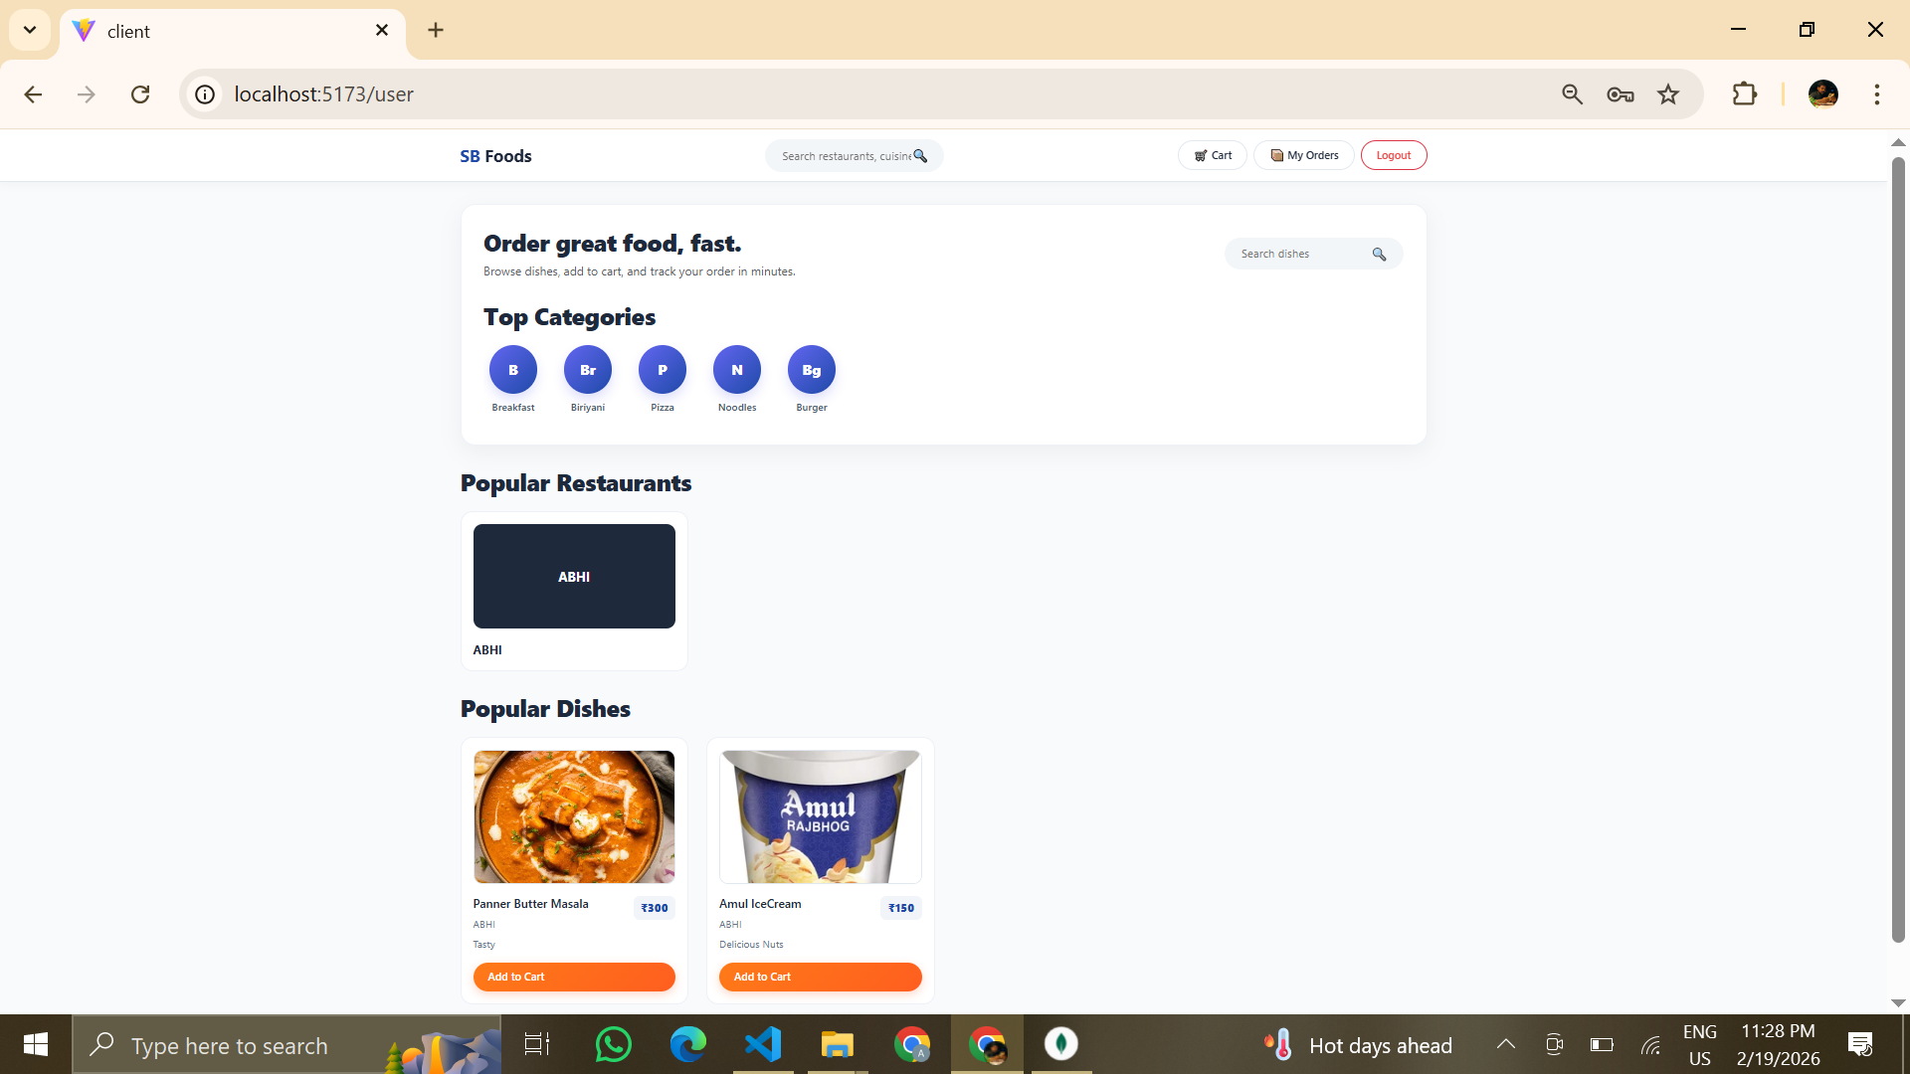

Figure: Customer Dashboard

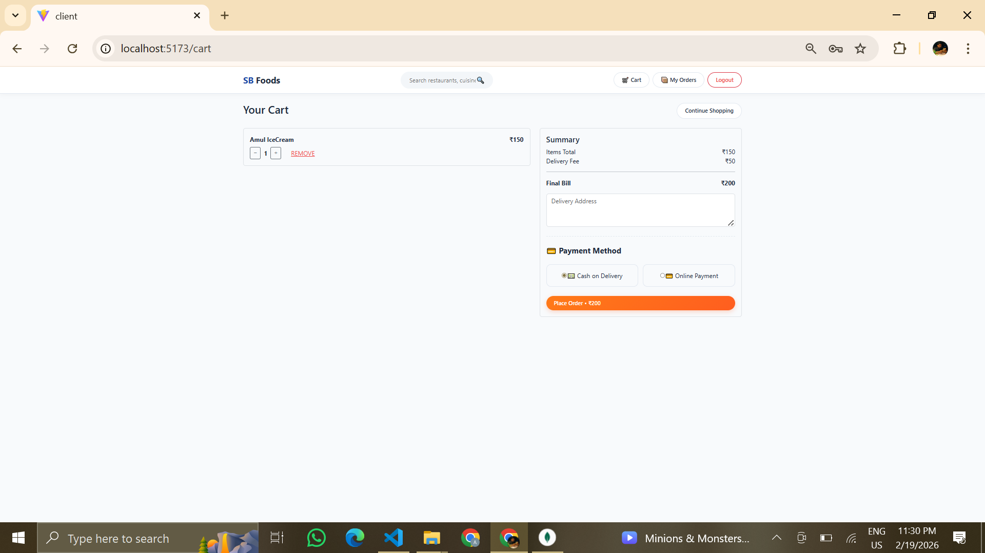

Figure: Cart Page

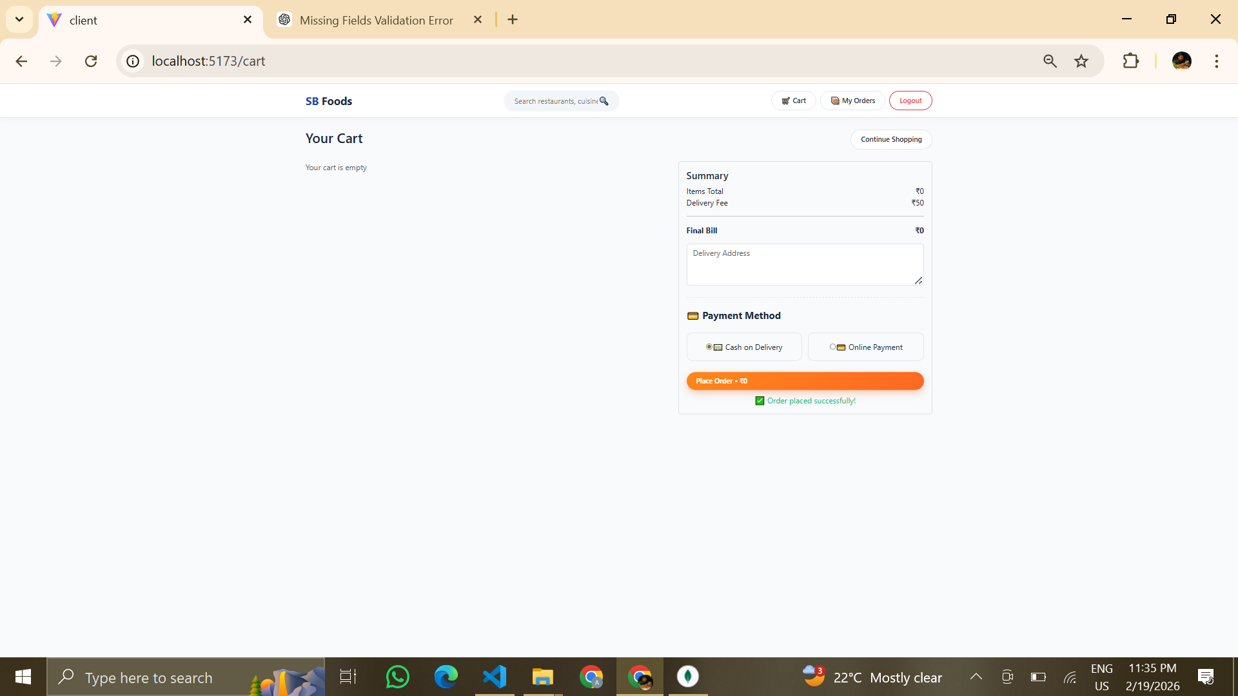

Figure: Order Success Page

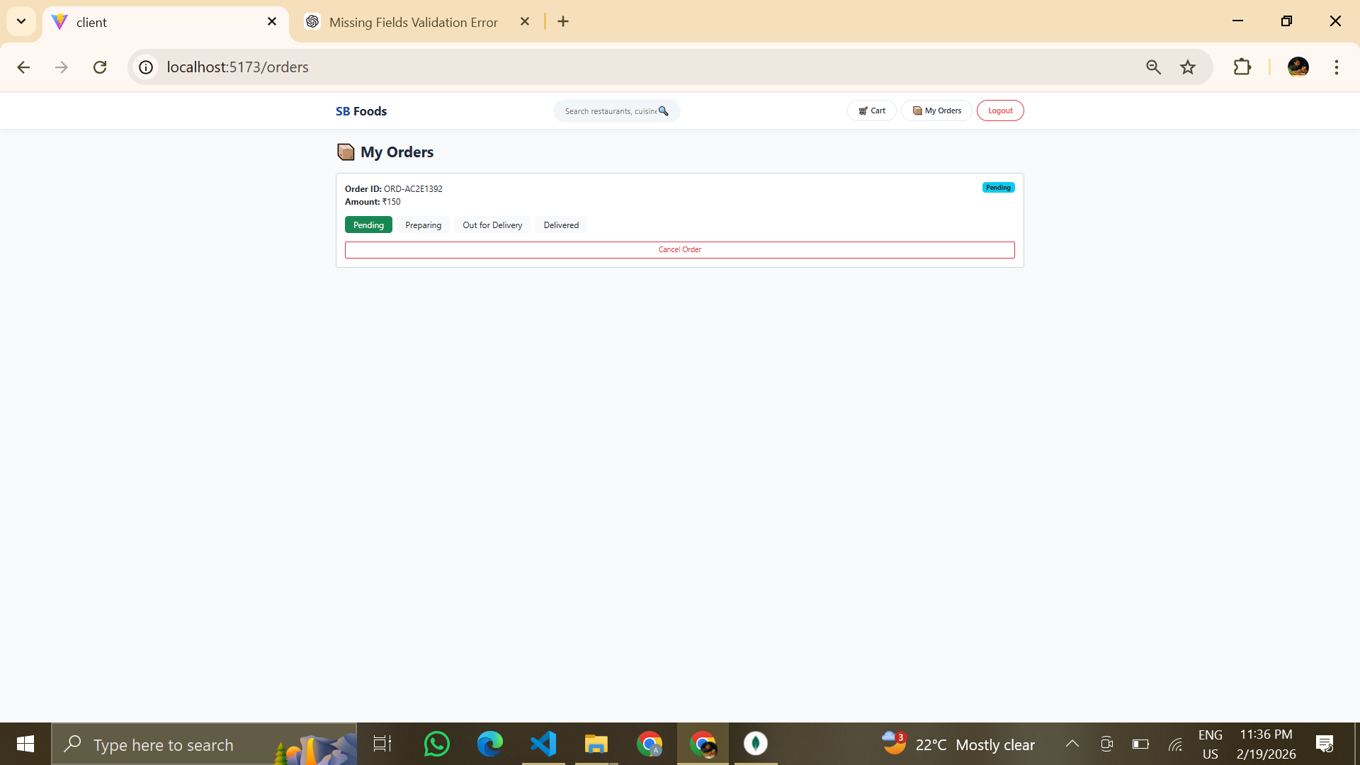

Figure: Order Status Tracking

**RESTAURANT:**

**MODULE OUTPUTS**

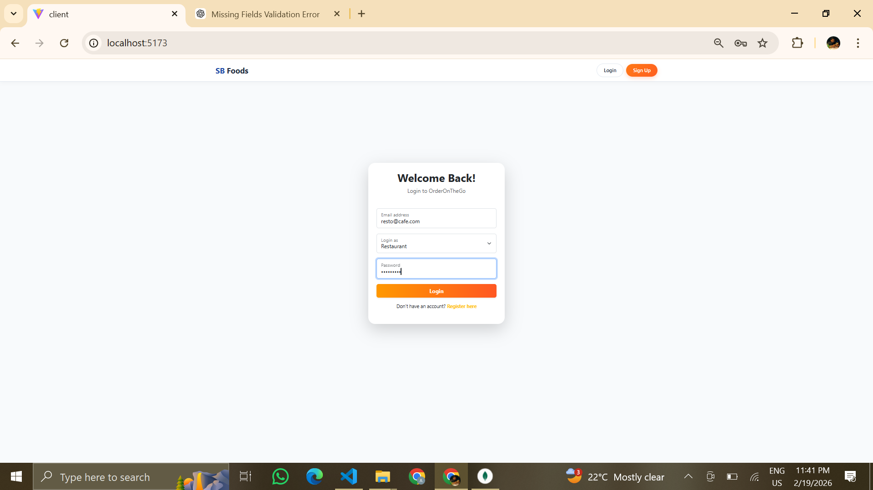

Figure: Restaurant Login

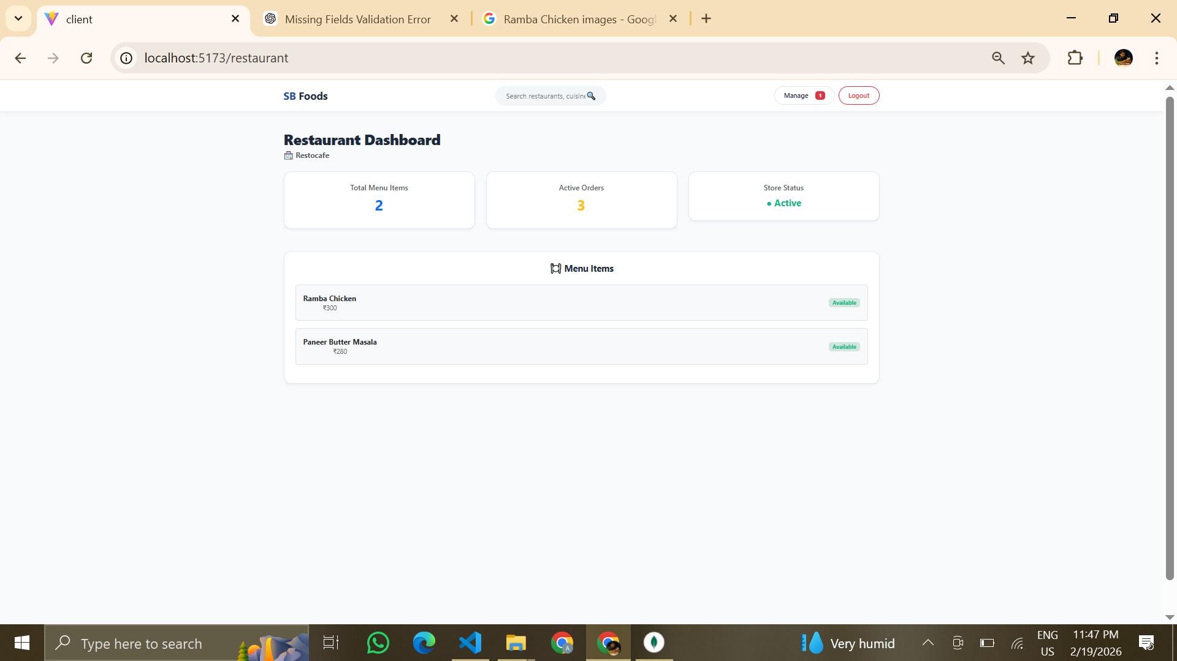

Figure: Restaurant Dashboard

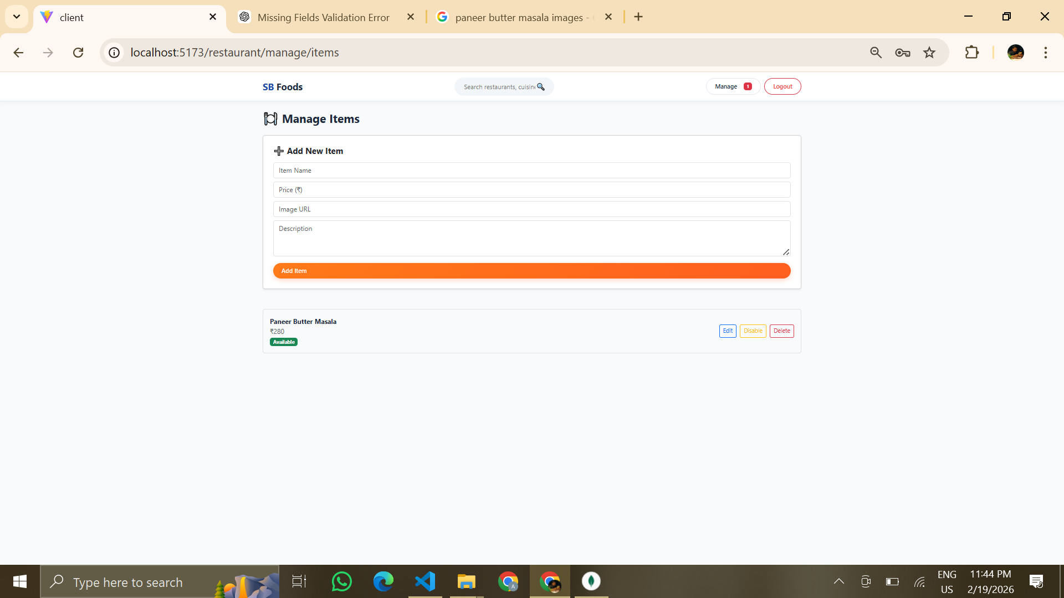

Figure: Manage Items

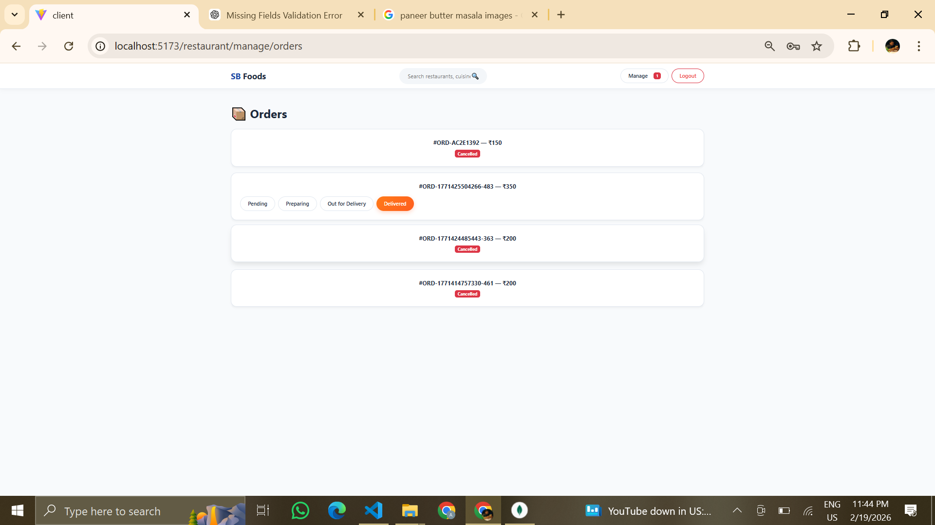

Figure: Manage Orders

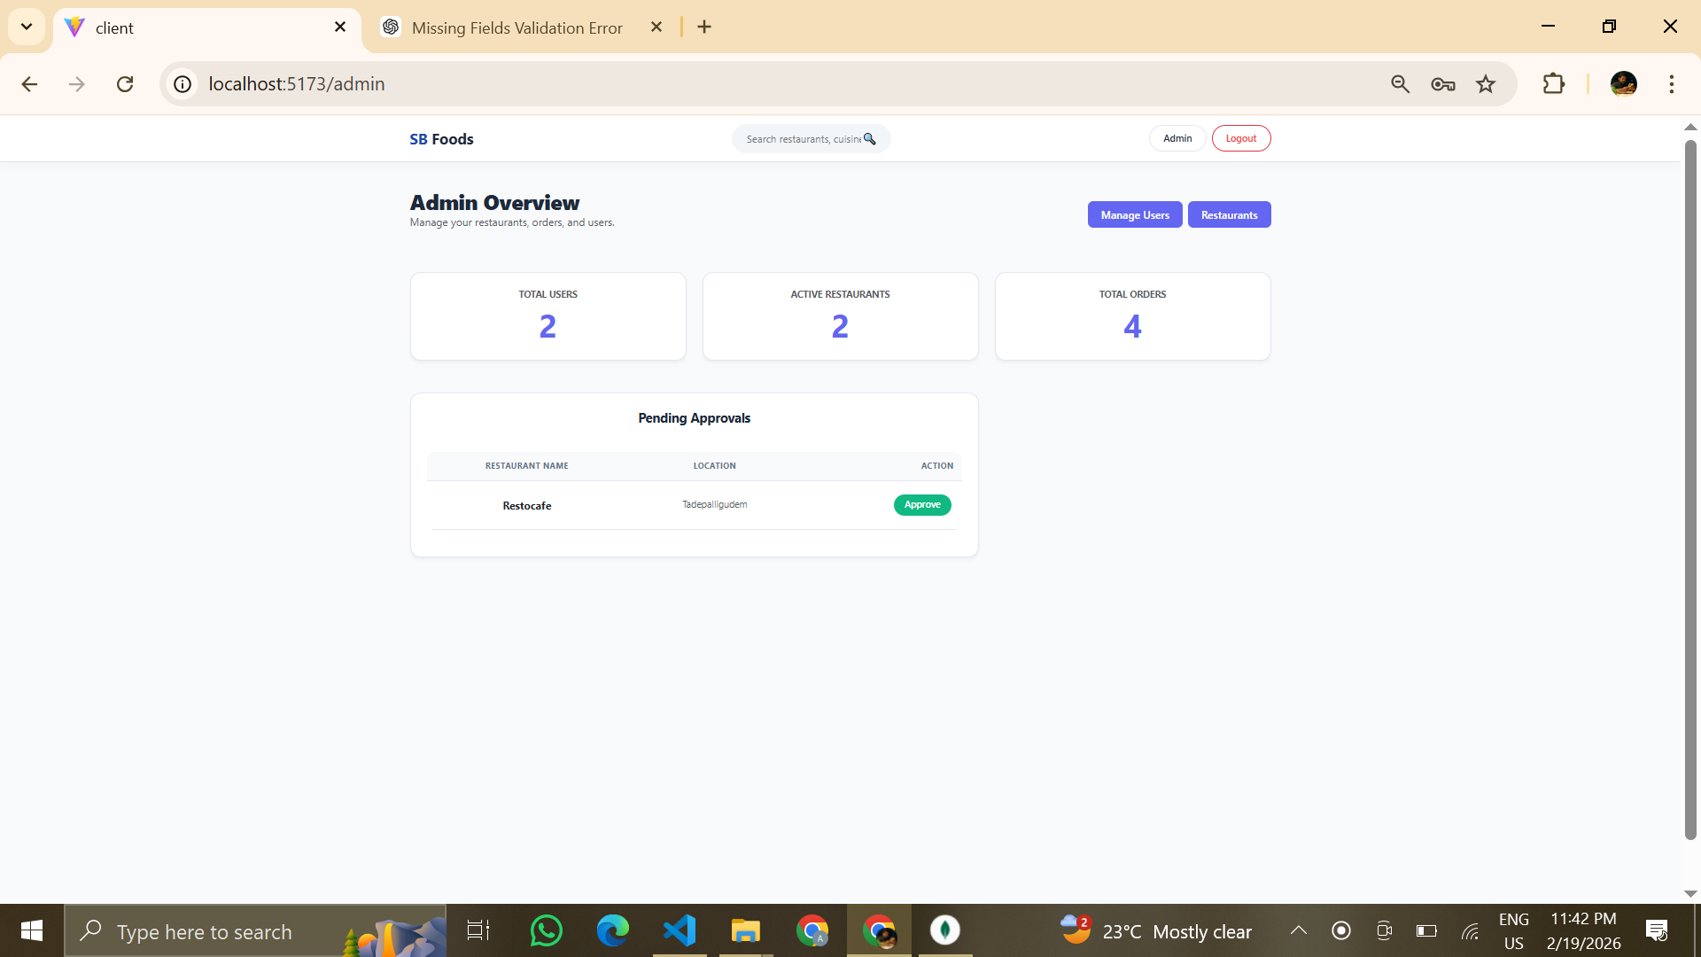

Figure: Waiting for Approval

**8. ADVANTAGES & DISADVANTAGES**

### Advantages

**Secure Authentication and Authorization**  
The system implements JWT-based authentication and bcrypt password hashing, ensuring secure login, encrypted credentials, and role-based access control for Customers, Restaurants, and Admin users.

**Scalable MERN Architecture**  
Built using the MERN stack (MongoDB, Express.js, React.js, Node.js), the application supports scalability and modular expansion. Additional features can be integrated without affecting the core system structure.

**Modular and Layered Design**  
The system follows a clean separation of layers (Frontend, Backend, Authentication, Database, and Payment). This modular approach improves maintainability, debugging, and future upgrades.

**Centralized Management System**  
Admin users can monitor customers, restaurants, and orders through a single dashboard. This ensures better control, transparency, and operational efficiency.

**Role-Based Dashboard Access**  
Separate dashboards for Customers, Restaurants, and Admin ensure structured workflow and restricted access to sensitive operations.

**Integrated Payment System**  
Razorpay integration enables secure online transactions, enhancing reliability and user trust in the ordering process.

**Efficient Order Management**  
Customers can track orders, restaurants can update order status, and administrators can oversee transactions, making the entire workflow organized and transparent.

**Responsive User Interface**  
The React-based frontend ensures smooth navigation and responsive design across multiple devices.

### Disadvantages

**Dependency on Internet Connectivity**  
The application requires continuous internet access for both frontend and backend communication, limiting usability in offline environments.

**Server Availability Requirement**  
The backend server must remain active to handle requests. Downtime can temporarily affect ordering and management operations.

**Scalability Depends on Hosting Infrastructure**  
While the architecture is scalable, performance depends on the quality of hosting, server configuration, and database optimization

**Limited Offline Functionality**  
Since it is a web-based application, users cannot browse or place orders without network access.

**Basic Real-Time Tracking**  
Real-time order tracking can be further enhanced using technologies such as WebSockets for live updates.

**Maintenance and Security Updates Required**  
Regular updates and monitoring are necessary to maintain security, performance, and compatibility with new technologies.

**9. CONCLUSION**

OrderOnTheGo successfully demonstrates the practical implementation of a full-stack MERN (MongoDB, Express.js, React.js, Node.js) web application integrated with role-based authentication and a secure payment system. The project effectively combines frontend responsiveness, backend business logic, and database management into a unified and scalable architecture.

The system provides a structured and efficient solution for online food ordering by enabling Customers to browse menus, place orders, and track deliveries; Restaurants to manage food listings and orders; and Admin users to monitor and control overall platform operations. The implementation of JWT-based authentication and bcrypt encryption ensures secure access control, while Razorpay integration enhances reliability in online transactions.

Through modular design, clean separation of layers, and RESTful API communication, the platform achieves maintainability, scalability, and performance efficiency. The project not only addresses real-world food ordering challenges but also demonstrates strong understanding of full-stack development concepts, role-based access control, API integration, and database design.

Overall, OrderOnTheGo serves as a practical, secure, and scalable digital solution that bridges the gap between customers and restaurants through modern web technologies.

**10. FUTURE SCOPE**

Although OrderOnTheGo provides a complete and functional online food ordering system, several enhancements can be implemented to further improve performance, scalability, and user experience.

**Real-Time Order Tracking**  
Implementing WebSockets or Socket.io can enable live order status updates between customers and restaurants. This would provide instant notifications for order confirmation, preparation status, and delivery progress.

**AI-Based Food Recommendation System**  
Machine learning algorithms can analyze user preferences, order history, and behavior patterns to recommend personalized food items. This would enhance customer engagement and improve sales.

**Mobile Application Development**  
Developing a dedicated Android and iOS mobile application using React Native or Flutter would increase accessibility and user convenience, providing a smoother mobile experience.

**Cloud-Based Deployment**  
Migrating the application to cloud platforms such as AWS, Azure, or Google Cloud would improve scalability, reliability, and performance. Cloud hosting would also allow automatic scaling during peak usage.

**Advanced Analytics Dashboard**  
Adding analytical features for restaurants and administrators can provide insights into sales trends, popular items, peak hours, and revenue statistics.

**Enhanced Security Features**  
Implementing multi-factor authentication (MFA), secure HTTPS deployment, and rate-limiting mechanisms would further strengthen system security.

**Live Chat & Customer Support Integration**  
Integrating a real-time chat feature between customers and restaurants can improve communication and customer satisfaction.

**Coupon & Promotional System**  
Introducing discount coupons, promotional offers, and loyalty programs can enhance marketing strategies and increase customer retention.

With these enhancements, OrderOnTheGo has strong potential to evolve into a production-ready, enterprise-level food ordering platform capable of handling large-scale real-world operations

Submitted By:

**Team Leader :** Om Abhiram Beella

**Team member :** Velugula Hemanth

**Team member :** Sriya Badampudi

**Team member :** Teki Vijayaratnam